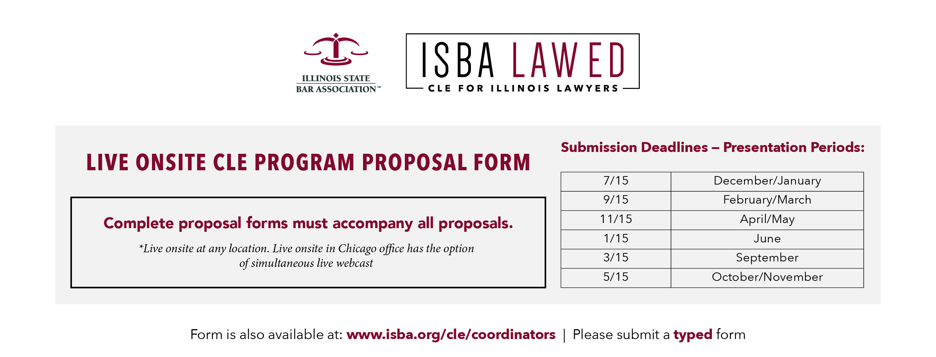

Please complete the following template and proposal information, adjusting as necessary.

- Proposed Program Title (keep it short, simple and catchy!)
- Presented by: (Sponsoring Section(s)/Committee(s))
- Co-sponsored by: (optional, but co-sponsoring sections/committees get discounts and broaden marketing base)
- Location – City/Venue
- Date(s) requested (Check Master Curriculum Calendar or confirm availability with ISBA staff)
- Program times (Minimum of 3.5 hours MCLE for live onsite audience. Shorter programs are webcasts/webinars. Indicate hours, full, or half-day)
- I request a simultaneous Live Webcast of the program.
- hour(s) MCLE credit, including hour(s) Professional Responsibility MCLE credit in the following category(ies) (PMCLE not required, but if offered, must be a minimum of one hour for full day programs and a minimum of one-half hour for half day programs):
- hour(s) Professionalism, Civility, or Legal Ethics MCLE credit (not required)
- hour(s) Mental Health and Substance Abuse MCLE credit (not required)
- hour(s) Diversity and Inclusion MCLE credit (not required)

- Topics Covered:
- Learning Objectives: What is the specific need this program addresses? What would you tell someone to convince him/her to register for it? What will attendees take away?
- Learning objective 1
- Learning objective 2
- Learning objective 3 . . . (add more as needed)

- Practice Level Targeted: Basic Intermediate Advanced

Program Coordinator(s):
Name, Firm, Address, Telephone Number, E-mail Address

Program Moderator(s):
Name, Firm, Address, Telephone Number, E-mail Address

- Check the box if the segment could be a stand-alone program or a practice ready basics program for new attorneys in the on-demand CLE catalog - to satisfy the increasing member demand for shorter, just-in-time learning segments.

- Adjust template segment times below in quarter hour increments, minimum 30 minutes, and add speakers as needed

TIME Welcome and Announcements (suggested start time: 8:30-9:00 a.m. for a full day or morning only program or 12:30-1 p.m. for an afternoon only program)

TIME Topic 1
Description (2-3 sentences)
Speaker, Firm, Address, Telephone Number, E-mail Address
Could be stand-alone program in on-demand CLE catalog
Could be a stand-alone practice ready basics program for new attorneys in on-demand CLE catalog

TIME Topic 2
Description (2-3 sentences)
Speaker, Firm, Address, Telephone Number, E-mail Address
Could be stand-alone program in on-demand CLE catalog
Could be a stand-alone practice ready basics program for new attorneys in on-demand CLE catalog

TIME Break (beverages provided)

TIME Topic 3
Description (2-3 sentences)
Speaker, Firm, Address, Telephone Number, E-mail Address
Could be stand-alone program in on-demand CLE catalog
Could be a stand-alone practice ready basics program for new attorneys in on-demand CLE catalog
For full day programs, include the following:

TIME Lunch on your own provided by ISBA (we will add $15 to fee) sponsored by financial contributor, indicate name and contact information

TIME Topics 4 , 5, 6, etc.(Full day programs should go until at least 4:00 p.m.)
Description (2-3 sentences)
Speaker, Firm, Address, Telephone Number, E-mail Address
Could be stand-alone program in on-demand CLE catalog
Could be a stand-alone practice ready basics program for new attorneys in on-demand CLE catalog

15 Minute Break will be added in the afternoon (refreshments provided)

*Professional Responsibility MCLE credit subject to approval

Additional Information

- Financial Contributors (optional): I have secured financial contributors for this program and have reviewed and followed the guidelines of ISBA’s Financial Contributor Policy. Financial Contributor’s Name(s) for publicity, address, phone, email, and amount pledged:

- (optional) I Request ISBA’s assistance in setting up a pre-program teleconference with all panelists/speakers.

- Publications (optional): To help with program promotion, please identify one or more authors to write on program topics for an Illinois Bar Journal, newsletter article, or Illinois Lawyer Now blog post related to this CLE program. ISBA staff will contact this person with details about the submission process.

For marketing, please indicate which of the following groups
might be interested in this program:

ISBA Sections
Administrative Law
Agricultural Law
Alternative Dispute Resolution
Animal Law
Bench & Bar
Business Advice & Financial Planning
Cannabis
Child Law
Civil Practice
Commercial Banking, Collections & Bankruptcy
Construction Law
Corporation Securities & Business
Corporate Law Department
Criminal Justice
Education Law
Elder Law
Employee Benefits
Energy, Utilities, Transp. & Telecomm.
Environmental Law
Family Law
Federal Civil Practice
Federal Tax
Food Law
General Practice/Solo & Small Firm
Health Care
Human Rights
Insurance Law
Intellectual Property
International & Immigration Law
Labor & Employment

Local Government
Mental Health Law
Mineral Law
Privacy & Security Law
Real Estate
Senior Lawyers
State & Local Tax
Tort Law
Traffic Laws & Courts
Trusts & Estates
Workers' Compensation
Young Lawyers
ISBA Committees
ARDC
Corrections and Sentencing
Delivery of Legal Services
Disability Law
Government Lawyers
Law Office Management & Economics
Legal Technology
Military Affairs
Racial and Ethnic Minorities
Sexual Orientation and Gender Identity
Women and the Law
Other
Certified Public Accountants* (*ISBA is approved as a registered public accountant continuing professional education (CPE) sponsor.)

Additional Steps
- Review the following “CLE Coordinator Checklist” prior to completing your proposal.
- Distribute the attached “Law ED Presenter Information” to your confirmed speakers.(also available online at www.isba.org/cle/coordinators)
- Attach any additional program agenda information to this completed form in Microsoft Word and send to:

CLE Department, Attn: CLE Program Coordinator
ISBAProgramCoordinator@isba.org
Illinois State Bar Association, 424 South Second Street, Springfield, IL 62701
Thank you for your proposal!

Thank you for your proposal!

Program Composition

Did you…
- Identify the program’s “learning objectives” – that is, what attendees will take away, why they should attend this program, what specific needs will be addressed?
- Identify the type of practitioners and level of practice experience for which the program is designed – and then schedule the speakers for presentation times measurable in quarter-hour increments (15, 30, 45, 60), except introductory and closing remarks?
- Schedule an identifiable segment of Professional Responsibility credit, if included, of not less than one hour for full day programs and not less than one-half hour for half day programs, in increments of 15 minutes?
- Provide two to three sentence descriptions for each session, including what the attendees will learn?
- Incorporate Questions and Answers into the program, rather than ending the seminar with a Q and A session (unless you’re preparing questions in advance to make sure the full advertised MCLE credit time is provided)?

Presenter Recruitment

Did you…
- Recruit the best, most effective presenters on the topic, whether or not they serve on the section or committee?
- Recruit presenters who reflect the geographic, ethnic, and gender diversity of the bar?
- Recruit presenters or co-presenters who are attorneys in their first 10 years of practice as a way to train and develop new ISBA Law Ed faculty members?
- Recruit only presenters who will agree to submit materials 4 weeks prior to program so ISBA may apply for PMCLE credit and so we avoid handouts at programs since attendees attending remotely will not have access to the handouts?
- Recruit presenters who agree to submit original materials or to secure written permission for ISBA to reprint copyrighted works in course books and electronic products?
- Recruit only presenters who will agree to be videotaped and who will sign the required Presentation Agreement?
- Recruit presenters who agree to arrive not less than 30 minutes prior to presenting?
- Recruit in-state presenters?
- Recruit presenters who are ISBA members or, in the case of non-members, invite them to join and direct them to the ISBA membership webpage at: www.isba.org/membership/join?

Presenter Support

Did you…
- Provide the attached ISBA LawEd Presenter Information to all invited speakers?
- Provide presenters with ISBA guidance on preparing materials and with other faculty resources at www.isba.org/cle/faculty?
- Provide written justification for selecting an out-of-state presenter? Please Note: Out-of-state presenters are subject to same reimbursement rates as in-state presenters:
  - Rail or coach class airfare not to exceed $350.00
  - Automobile travel costs of 40¢ per mile
  - Actual lodging at single room rates not to exceed $250 per day for one night’s lodging
Moderator Selection

Did you…
- Select a moderator who will keep the program running on time, capture audience questions via microphone, and assist presenters during the program?
- Select a single moderator or select an already-identified presenter to assist in moderating (because only one moderator will be reimbursed for travel/hotel per program. Complimentary registration is provided for one moderator for half-day programs and two moderators for full-day programs. Additional moderators can attend for $25)?
- Select a moderator who is an ISBA member and a sponsoring section council or committee member, preferably with Law Ed experience (coordinator, chair, or presenters are recommended)?

Proposal Submission

Did you…
- Provide a list of confirmed presenters and full contact information for each of them, as well as the moderator’s e-mail address and phone number?
- Type, rather than handwrite, the program proposal cover sheet and agenda?
- Submit the Program Proposal to ISBA staff on or before the submission deadline?
- Know that if your program agenda is lacking sufficient information to market and price the program by 6 weeks before the presentation date, ISBA reserves the right to postpone or reschedule the presentation date and may require resubmission of the proposal to the CLE committee?

Communicating with Presenters For a Better Program

Did you…
- schedule a telephone conference 7 - 8 weeks prior to the program for all presenters, the moderator and yourself to confirm topics, reinforce materials deadlines, and address questions? (Contact ISBA if you would like ISBA assistance in providing you with telephone conference capabilities.)

Thank you for agreeing to speak for the ISBA!

What you can expect:

- Contact from the ISBA CLE Coordinator to confirm the dates and times for your presentation.
- Contact from the ISBA CLE Department regarding deadlines and program information.
- Publicity for you and your firm in ISBA brochures, marketing emails, and/or color flyers, as well as on our website and in the course materials.
- A speaker invitation letter that you can use to invite all your peers to the program.
- Complimentary preparation time MCLE credit at 6 times your actual presentation time.
- Complimentary registration to the program at which you are speaking.

What ISBA Expects:

- Your agreement to submit written materials, legal forms, and/or PowerPoint presentation at least 4 weeks prior to program date.
- Your agreement to submit original materials or to secure written permission for ISBA to reprint copyrighted works in course books and electronic products.
- Your agreement to arrive not less than 30 minutes prior to presenting.
- Your membership in ISBA – or consideration to join ISBA.
(http://www.isba.org/membership/join)
- Your agreement to be videotaped by submitting a signed ISBA presentation agreement.
- Your agreement to review the Checklist for Professional Responsibility topic presentations if you are presenting a segment that qualifies for PMCLE credit. (www.isba.org/sites/default/files/cle/coordinators/IL%20Commission%20on%20Professionalism%20Checklist.pdf)
- Your review and completion of all or part of ISBA’s Faculty Development Series. (www.isba.org/cle/faculty)
- Your agreement to comply with the ISBA travel reimbursement guidelines and limitations.

